Word 2003 - Method for Scaling Station Roster to Print

In the Volunteer Reporter, open the Station Roster Spreadsheet.

Spreadsheets | Station Spreadsheets | Station Roster

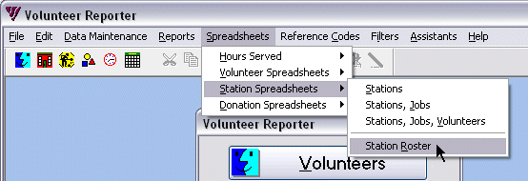

Complete your organization’s profile [Grant number, sponsor, etc.] and select the appropriate date. The profile will not have to be filled out the next time.

Check the Last Renewed MoU Date.

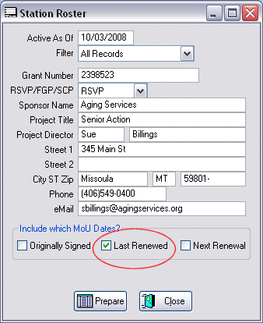

Click Prepare.
To setup scaling to print all the columns on the first page, click File | Page Setup…

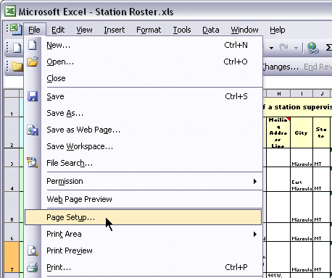

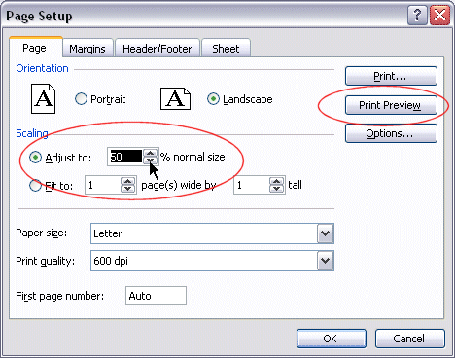

Adjust the scaling to 50%.

Word 2007 Method for Scaling Station Roster

Adjust the Scale to 50%

